Name :…………………………………………………

**Summer School – HTML, CSS, JavaScript**

*10 August 2018*  
*40 Minutes, Closed Book*

|  |  |
| --- | --- |
| * Do not forget to write your name on this page * Write your initials on the top of ALL pages * This exam is closed book, closed lecture notes, and closed personal notes. * Any attempt to cheat will be punished seriously. * Show your work and reasoning clearly and write legibly, only within the space provided for each question. Do not detach any page(s). * You can ask questions should you need clarification about the exam questions. . |  |

**Questions (Each question are 5 points. Total 100 Poınts)**

1. What are the components of a CSS Style?

Selector, Property, value

1. In how many ways can a CSS be integrated as a web page?

Inline: Style attribute can be used to have CSS applied HTML elements.

Embedded: The Head element can have a Style element within which the code can be placed.

Linked/ Imported: CSS can be placed in an external file and linked via link element.

1. What is the CSS selector which allows you to target every element in a web page?

*

1. Which CSS property allows you to hide an element but still maintain the space it occupies in the web page?

visibility or opacity

1. What is the difference between Class selector and ID selector?

While an overall block is given to class selector, ID selector prefers only a single element differing from other elements. In other words, ID are uniques while classes are not. Its possible that an element has both class and ID.

1. How can the dimension be defined of an element ?

Height, Max-height, Max-width, Min-height, Min-width

1. How comments can be added in CSS?

The comments in CSS can be added with /* and */.

1. What is a child selector? Show in an example.

body > p {

color: #000000;

}

1. Write an example of Attribute selector.

input[type = "text"]{

color: #000000;

}

1. How to select all div elements with a lang attribute?

div[lang]

1. How to select all paragraph elements whose lang attribute has a value of exactly “tr”?

div[lang=“tr”]

1. Which property is used to set the background color of an element?

background-color

1. Which is the correct CSS syntax?
   1. body:color=black;
   2. {body:color=black;}
   3. {body;color:black;}
   4. body {color: black;}
2. How do you add a background color for all <h1> elements?
   1. h1 {background-color:#FFFFFF;}
   2. h1.all {background-color:#FFFFFF;}
   3. all.h1 {background-color:#FFFFFF;}
   4. all > h1 {background-color:#FFFFFF;}
3. Which CSS property controls the text size?
   1. font-size
   2. text-size
   3. font-style
   4. text-style
4. What is the correct CSS syntax for making all the <p> elements bold?
   1. <p style="font-size:bold;">
   2. p {text-size:bold;}
   3. p {font-weight:bold;}
   4. <p style=“text-size:bold;">
5. How do you display a border like this:

The top border = 10 pixels

The bottom border = 5 pixels

The left border = 20 pixels

The right border = 1pixel?

* 1. border-width:10px 1px 5px 20px;
  2. border-width:10px 20px 5px 1px;
  3. border-width:10px 5px 20px 1px;
  4. border-width:5px 20px 10px 1px;

1. Which of the following selector is used to select and style when you place mouse over it?
   1. focus
   2. hover
   3. mouse
   4. all of the mentioned

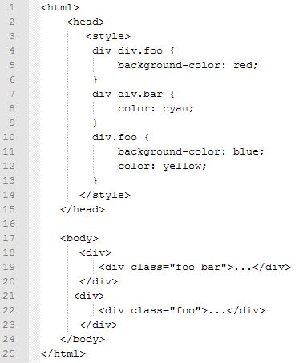

1. What are the background colors of the div elements on lines 19 and 22?

red,red

1. What are the text colors of the div elements on lines 19 and 22?

cyan, yellow